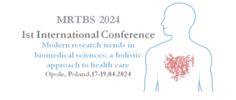

**Title: Times New Roman 14, bold, centered**

Authors: Full Name SURNAME a, Presenting Author UNDERLINED a,b, Times New Roman 12 pt, centered

*a affiliation of Author(s) including the full name of the institution, city, country, Times New Roman 12 pt, italic, centered*

*b affiliation of Author(s) including the full name of the institution, city, country*

***e-mail*** *and phone number of the presenting Author*

Keywords: max. 6 words from the Medical Subject Headings 2024 catalog: <https://meshb-prev.nlm.nih.gov/>

Main text of the abstract (divided into 5 parts: introduction, aim, material and methods, results, and conclusions);

Please do not include references, figures, diagrams, or photographs in the abstracts;

Required formatting: Times New Roman 12 pt with single-spaced, justified.

The length of the abstract (excluding title, name of the author/co-authors, and affiliation) must not exceed 2,200 characters (including spaces) or 300 words.